

Immovable Asset Management in

National and Provincial Government

Guideline For Users
User Asset Management Plans

Version 1
February 2017
Table of Contents
GLossary of terms relevant to Immovable Asset Management 3
Part 1: Introduction 6
Part 2: Framework and contents of a U-AMP 9
Section 1: Introduction 9
Section 2: Immovable asset requirements 9
Section 3: Acquisition plan 10
Section 4: Refurbishment plan 10
Section 5: Repairs 11
Section 6: Surplus immovable assets 11
Section 7: Budget and funding of accommodation 11
Section 8: Plan Improvement and monitoring 12
Part 3: Process for preparing a U-AMP 13
Introduction 13
Process 1: Match immovable asset requirements with service delivery objectives 13
Process 2: Verify the assets occupied or allocated to User 14
Process 3: Determine functional performance of assets 14
Process 4: Determine utilisation of accommodation 14
Process 5: Conduct gap analysis 15
Process 6: Determine new immovable requirements 16
Process 7: Determine need for refurbishment or reconfiguration 17
Process 8: Determine surplus assets to be surrendered 17
Process 9: Determine repairs that need to be conducted 18
Process 10: Preparation of immovable asset budget 18
Part 4: Templates for preparing a U-AMP 19
Template 1: Extraction from Asset Register (Annexure A of the U-AMP) 20
Template 2: Additional Space Requirements (Annexure B of the U-AMP) 21
Template 3: Infrastructure (Capital & Maintenance) Requirements (Annexure C of the U-AMP) 22
Template 4: Surrender Plan: (Annexure D of the U-AMP) 23
Template 5: Budget Requirements: (Annexure E of the U-AMP) 23
Part 5: Examples of Norms and Standards 24
Methodology for determining functional performance of assets 24
Utilisation Assessment for office accommodation 32

Glossary of terms relevant to

Immovable Asset Management
Acquisition means:
  - for national government, acquisition through construction, purchase, lease, acceptance of a gift, expropriation, exchange or transfer of custodianship between Custodians in that sphere of government; and
  - for provincial government, ‘‘acquire’’ as defined in the relevant provincial land administration law or transfer of custodianship between Custodians in that sphere of government.
Custodian means a national or provincial department designated in terms of GIAMA that must plan, acquire, manage and dispose immovable assets.
Immovable Asset means any immovable asset acquired or owned by government. Immovable assets are further described as land and any immovable improvement on that land, and which have enduring value and consist of assets of residential, non-residential or infrastructure nature and include machinery and equipment that have been installed and are an integral part of immovable assets and include all assets both state-owned and leased.
The application of the definition means that the types of assets listed below, will be construed to be immovable assets for the purposes of this guideline.
- Land including but not limited to developed, undeveloped, vacant, cultivated, non-useable or inaccessible land.
- Buildings including but not limited to office accommodation, prison buildings, police stations, courts, schools, hospitals, and houses.
- Rights in land including servitudes, “right to use”, leases.
- Infrastructure including but not limited to roads, harbours, railway lines, airports, transmission lines, dams and pipe lines.
- Machinery, plant and equipment including but not limited to pump stations, machinery and irrigation systems for as far as such machinery, plant and equipment are construed to be immovable in terms of the common law applicable to property.
- Conservation, cultural and heritage assets including but not limited to monuments, historical sites, heritage sites, conservation areas and sites of scientific significance.
Immovable Asset Management means those management processes, which ensure that the value of an immovable asset is optimised throughout its lifecycle.
Lifecycle means the National Treasury prescribed period (per asset class) during which a Custodian could expect to derive economic benefits from the control of an immovable asset.
Repair and Maintenance means actions required to reinstate an immovable asset to its original state when such asset is damaged accidentally or maliciously and all work on existing immovable asset that is undertaken to:
- prevent deterioration and failure;
- restore the immovable asset to its specified level of operation;
- restore the physical condition to specified standards;
- recover the immovable asset from structural and service failure; and
- partial equivalent replacement of components of the immovable asset.
Immovable asset maintenance excludes:
- improvements and upgrading to meet new service capacity or functions;
- refurbishment to new condition to extend the capacity or useful life;
- replacement of major components to extend the capacity or useful life;
- upgrading to meet new statutory requirements;
- operational tasks to enable occupancy use (e.g. cleaning, security, waste removal);
- supply of utilities (energy, water and telecommunications);
- construction of new assets; and
- major restoration as a result of natural and other disasters.
Operations plan is a plan, as agreed between the User and Custodian, for the scheduling of and budgeting for the management processes that ensure that the value of an immovable asset is optimised throughout its life cycle, including, maintenance and repair, for all immovable assets (or parts of immovable assets) allocated by the Custodian for use by the User over at least the forthcoming MTEF cycle. Electricity and water consumption optimization should be included in the operations plan.
Reconfiguration means the implementation of activities to make changes to the configuration of an immovable asset and thereby changing the functionality of the asset. An example of reconfiguration is to make changes to the internal walls of a building to develop open plan offices. Reconfiguration cannot be classified as maintenance as it comprises changes requested by a User to increase the functionality of the asset to contribute towards the achievement of service delivery objectives. A User therefore initiates reconfiguration, whereas a Custodian initiates maintenance, renovation or refurbishment.
Refurbishment/Renovation means comprehensive capital works actions intended to bring an immovable asset back to its original appearance, state or to extend its lifecycle. It may also be required for historical preservation. Refurbishment generally takes place at the end of an asset’s lifecycle to extend the lifecycle and gain further income potential from the asset. Renovation works do not necessarily extend functionality or the life of the asset, but are necessary for the planned life to be achieved. In such cases, the capital value of the asset is not affected.
Upgrade (extension, addition) means comprehensive capital works that increase the value of an existing immovable asset and extends the area of or add new functionality to the asset. Upgrades can take place at any time through the lifecycle of the asset and will increase the income potential of the asset. A User therefore initiates upgrades, whereas a Custodian initiates maintenance, renovation or refurbishment.
Strategic Needs Assessment is an assessment of the immovable assets required by the User for the implementation of the current strategic plan of the User over at least the forthcoming MTEF cycle. The strategic plan is as prescribed in terms of the Public Service Act, 1994 (Proclamation R103 of 1994) and the Public Finance Management Act, 1999 (Act No. 1 of 1999). This should include, for all immovable assets identified, list the type/function of immovable asset, the location of the immovable asset, the floor area of the immovable asset and other ancillary areas such as parking, the performance standard of the immovable asset and any specific requirements not typically associated with such an immovable asset
Strategic plan means the strategic plan of a Custodian or User as prescribed in terms of the Public Service Act and the PFMA.
Surplus in relation to an immovable asset means that the immovable asset no longer supports the service delivery objectives of a User.
Surrender plan is a plan, as agreed between the User and Custodian, for the relinquishment of immovable assets (or parts of immovable assets) by the User to the Custodian over at least the forthcoming MTEF cycle, where the immovable assets (or parts of immovable assets) will no longer support the service delivery objectives of a user in terms of the strategic needs assessment currently or during the forthcoming MTEF cycle
Useful life means the period during which a User derives benefit from the use of an immovable asset.
User means a national or provincial department that uses or intends to use an immovable asset in support of its service delivery objectives (and includes a Custodian in relation to an immovable asset that it uses or intends to use in support of its own service delivery objectives).

Part 1: Introduction
- The purpose of this document is to guide National and Provincial Departments through the preparation of User immovable asset management plans (U-AMP). This document consists of five parts:
  - Part 1: Background and introduction.
  - Part 2: Framework for the minimum content of a U-AMP.
  - Part 3: Process of preparing a U-AMP.
  - Part 4: Templates for a U-AMP.
  - Part 5: Examples of accommodation norms and standards.
- The Government Immovable Asset Management Act, No 19 of 2007 (GIAMA), seeks to introduce measures to ensure a uniform framework for the management of immovable assets that are used by (or is reserved for) a national or a provincial department in support of its service delivery objectives.
- Historically, immovable asset management practices in government resulted in immovable assets slipping into disrepair due to improper funding and maintenance. In general, the culture of replacement rather than maintenance eventually cost government significantly more than what ongoing preventative maintenance would have cost. These practices in government were the result of a non-uniform governance framework and the lack of monitoring and evaluation systems.
- GIAMA outlines a framework of basic principles in accordance with which national and provincial government departments must manage the immovable assets that they use in delivering the services that they are mandated to deliver.
- GIAMA seeks to:
  - providing a uniform immovable asset management framework to promote accountability and transparency within government;
  - ensuring effective immovable asset management within government;
  - ensuring alignment of use of immovable assets with service delivery objectives of a national or provincial department and the efficient utilisation of immovable assets;
  - optimising the cost of service delivery through prudent allocation of limited state resources in relation to:
    - the accountability for capital and recurrent works;
    - the acquisition, re-use and disposal of an immovable asset;
    - the maintenance of existing immovable assets;
    - protecting the environment and the cultural and historic heritage; and
    - improving health and safety in the working environment.
  - clarify the role of Custodians and Users in relation to immovable assets owned or leased by the state;
  - outline the principles of immovable asset management to be maintained by government;
  - impose a duty on the accounting officer of every User and Custodian to submit immovable asset management plans, in line with the requirements for strategic planning as provided for by Public Finance Management Act and the Public Service Act;
  - determine the minimum content of immovable asset management plans;
  - determine the legal status of an immovable asset management plan;
  - provide for the administration of the Act, such as exemptions, delegation and assignment, offences and penalties, as well as for the Minister to issue standards and guidelines for immovable asset management, with the concurrence of the Ministers of Finance and Public Service (the legal status of these standards and guidelines are also determined); and
  - enable the Minister to make regulations, and to regulate the matter in the transitional period by suspending requirements if and where necessary.
- In accordance with GIAMA the principles of immovable asset management are as follows:
  - an immovable asset must be used efficiently and becomes surplus to a User if it does not support its service delivery objectives at an efficient level and if it cannot be upgraded to that level;
  - to minimise the demand for immovable assets, alternative service delivery methods that do not require immovable assets must be identified and considered;
  - in relation to an acquisition, it must be considered whether—
    - a non-immovable asset solution is viable;
    - an immovable asset currently used by the state is adequate to meet a change in its service delivery objectives; and
    - the cost of the immovable asset as well as operational and maintenance cost throughout its lifecycle justifies its acquisition in relation to the cost of the service;
  - immovable assets that are currently used must be kept operational to function in a manner that supports efficient service delivery;
  - when an immovable asset is acquired or disposed of best value for money must be realised;
  - in relation to a disposal, the Custodian must consider whether the immovable asset concerned can be used:
    - by another User or jointly by different Users;
    - in relation to social development initiatives of government; and
    - in relation to government’s socio-economic objectives, including land reform, black economic empowerment, alleviation of poverty, job creation and the redistribution of wealth.
- Users of immovable assets utilise such assets to give best effect to their functions and therefore must produce a User Immovable Asset Management Plan (U-AMP) to ensure:
  - accountable, fair and transparent management of immovable assets;
  - effective, efficient and economic use of immovable assets;
  - reduced overall cost of service delivery;
  - reduced demand for new immovable assets.
- The process of compiling a U-AMP is integral to the strategic planning process in that the availability of immovable assets facilitates the achievement of service delivery objectives. It is therefore required to integrate immovable asset planning into the department’s strategic planning process. This is achieved by linking assets with programme delivery strategies and objectives during the compilation of corporate strategic plans. The immovable asset time frame should equate with the Medium Term Expenditure Framework (MTEF) and is aligned with the corporate planning horizon. By incorporating immovable asset planning into the strategic planning framework (and MTEF) the long-term implications of corporate level decision-making on immovable assets can be identified and appropriate responses developed.
- The accounting officer of a User must, jointly with the Custodian:
- assess the utilisation of its immovable assets in terms of service delivery objectives;
- assess the functional performance of its immovable assets;
- prioritise the need for repair, upgrade or refurbishment of state-owned immovable assets;
- plan for future immovable asset needs;
- communicate these needs to the Custodian in a structured fashion; and
- secure funds to pay for the utilisation of immovable assets.
- The accounting officer of a Custodian must:
- assist Users in the compilation of U-AMPs in accordance with section 13(2) of GIAMA;
- consolidate and assess Users’ needs in terms of total asset portfolio by means of options analyses (best value);
- determine full cost of immovable asset use (including cost to plan, acquire, operate, maintain, replace, reinstate or dispose of assets);
- plan for implementation of acquisition, repair, maintenance, refurbishment and disposal of assets;
- monitor performance of assets in terms of value, utilisation, full lifecycle costs, condition, occupational health & safety and service reliability;
- plan to provide appropriate assets to Users to fulfil service delivery needs at true cost.
- Custodians of immovable assets must plan to provide Users with appropriate immovable assets within budget constraints. This can be achieved through state-owned or leased assets and Custodians must prepare a Custodian Immovable Asset Management Plan (C-AMP) to state how they intend fulfilling the requirements of all Users within the norms and standards that will be prescribed by the Minister of Public Works. A guideline for the preparation of a C-AMP will be issued as a separate document.

Part 2: Framework and contents of a U-AMP
- To achieve the objectives of GIAMA, a U-AMP should consist of at least the following sections:
  - Section 1: An introduction that summarises the overall strategic intent of the User regarding its existing and long-term immovable asset requirements. The User must set objectives to improve the efficient and effective utilisation of the existing immovable assets and how it is going to measure itself to achieve such objectives. Service delivery objectives and immovable asset requirements as expressed in the User’s annual strategic plan and must be underpinned by budget programme objectives.
  - Section 2:
  - Section 3: Demand plan must contain a summary of current and proposed acquisitions, as informed by the impact of service delivery objectives.
  - Section 4: Refurbishment plan must contain a summary of current and proposed refurbishments and reconfiguration of existing immovable assets, as informed by the impact of service delivery objectives.
  - Section 5: Repairs required to reinstate immovable assets to their original state.
  - Section 4: Surplus immovable assets that no longer support the service delivery objectives of the User and must be surrendered to the Custodian.
  - Section 5: Budget requirements to fund immovable asset needs of the User.

- Each section must describe the immovable asset requirements and plans of a User in terms of the principles of immovable asset management (see paragraph 5) and must be supported by attachments (see part 4).

Section 1: Introduction

- The introduction of a U-AMP must summarise the overall strategic intent of the User regarding its existing and long-term immovable asset requirements. The User must set objectives to improve the efficient and effective utilisation of the immovable assets assigned to it and how it is going to measure itself to achieve such objectives, by addressing:
  - Improvement strategies.
  - Improvement objectives and targets.
  - Performance measures and utilisation benchmarks.

Section 2: Immovable asset requirements
- In this section a User should determine how immovable assets will support the achievement of service delivery objectives. When determining its immovable asset requirements, the User must consider:
  - legislation that may impact on service delivery;
  - approved and funded programme objectives;
  - functional requirements for service delivery;
  - required level of service; and
  - applicable immovable asset norms.
Where a norm for an immovable asset class (published under GIAMA) is not available, such a norm should be determined by using, in the following order:
- an applicable South African National Standard;
- international standard;
- prescripts by the supplier (in the case of specialised equipment); or
- a rational argument or design to satisfy immovable asset requirements.
- A User must demonstrate that immovable asset requirements are funded and ensure that existing immovable assets are matched to service delivery objectives. If the User’s requirements are not met by existing assets, it should:
  - assess the level to which existing immovable assets meets the functional requirements;
  - determine the gap between existing and required immovable assets; and
  - propose solutions to address the demand for additional immovable assets through more efficient and effective utilisation of existing assets.

Section 3: Acquisition plan
- The acquisition plan must consist of a summary of current and proposed acquisitions, as informed by asset requirements. For a User, acquisitions don’t necessarily imply newly constructed, purchased or leased immovable assets, but may also imply that the Custodian may make available existing immovable assets to the User.
- A User must differentiate those acquisitions where the Custodian has completed an options analysis from those acquisitions that were identified in the current planning cycle. Where available, the options analysis and cost benefit analysis must be attached to the U-AMP as an attachment.

Section 4: Refurbishment plan
- The refurbishment plan must consist of a summary of current and proposed refurbishments, reconfigurations and upgrades of immovable assets, as informed by the impact of service delivery objectives (as determined in section 2 of the U-AMP).
- From time to time it becomes necessary to improve the operation of an immovable asset in order to extend its lifecycle or to adapt or reconfigure the asset to meet new service delivery objectives for the same User. Such improvement is generally referred to as refurbishment. The refurbishment of an immovable asset may thus originate from two sources:
  - From the Custodian, based on the need to extend the lifecycle of the asset or improve its condition.
  - From the User, based on the need to improve the functional performance and utilisation of the asset.
- Where an immovable asset has been in use for its determined life between refurbishments, the Custodian must budget for the refurbishment of the asset. The U-AMP must however contain this information since it will influence the ability of the User to use the immovable asset during refurbishment.
- Where an immovable asset has only been used for a part of its lifecycle and a User requires refurbishment and reconfiguration, a Custodian may require a User to contribute to the refurbishment of the asset. A User needs to budget for such a contribution.

Section 5: Repairs
- Repairs, emanating from a breakage/failure, are required to reinstate an immovable asset to its original state. Where an asset is damaged accidentally or maliciously by a User, the User must budget for the required repairs to the asset.
- Repairs may be identified from the regular condition assessments a Custodian conducts on the immovable asset, or by the User. The U-AMP should only include the required repairs to reinstate the asset.

A User should not affect any repairs to an immovable asset without due consultation and agreement with the Custodian.

Section 6: Surplus immovable assets
- Immovable assets that no longer support the service delivery objectives of the User and that will be surrendered to the Custodian for alternative use or disposal must be identified in this section. The User must clearly indicate the date on which the asset will be vacated, subject to obligations in terms of existing contracts. Users will remain responsible for any financial obligations in terms of existing contracts and must therefore budget for such obligations.

Section 7: Budget and funding of accommodation
- A summary of all budgetary requirements over two MTEFs is prepared as a formal request for funding from the relevant treasury Budgets are derived and consolidated as a result of the completion of the various processes for preparing the U-AMP.

Capital budget requirements
- Users should apply to the relevant Treasury for capital budgets to fund the construction or purchase of immovable assets only for those acquisitions where the options and the cost benefit analyses have been completed. The planned acquisitions must be aligned to the User’s capital budget over the Medium Term Expenditure Framework (MTEF) cycle, as well as to the User’s funding requirements, as expressed in its annual submission to the Medium Term Expenditure Committee (MTEC).

Current/operational budget requirements
- Users should budget for current expenditure for all new immovable asset leases and long-term leases such as Public Private Partnerships.

Section 8: Plan Improvement and monitoring
- The purpose of this section is for Users to identify:
  - Improvements in the way that the User compiles a U-AMP.
  - Improvements that the User identified in support received from the Custodian during the compilation of the U-AMP.
  - Improvements to the U-AMP guidelines and format resulting from recommendations from Users and Custodians to the National Department of Public Works
- The above processes will enable annual improvements in the U-AMP guidelines as well as in support received from Custodians that will enable improvements in the quality of U-AMP developed.

Part 3: Process for preparing a U-AMP

Introduction
- During the preparation of a U-AMP, a User must conduct the following processes:
  - Process 1: Match asset requirements with service delivery objectives.
  - Process 2: Verify assets occupied by or allocated to the User.
  - Process 3: Determine functional performance of assets.
  - Process 4: Determine utilisation of assets.
  - Process 5: Conduct a GAP analysis.
  - Process 6: Determine new asset requirements.
  - Process 7: Determine the need for refurbishments or reconfiguration of existing assets.
  - Process 8: Determine surplus assets to be relinquished.
  - Process 9: Determine maintenance (planned and unplanned)
  - Process 10: Prepare budget requirement.

Process 1: Match immovable asset requirements with service delivery objectives
- Matching asset requirements with service delivery objectives is a key component of the asset planning process and forms part of the process of developing service delivery plans and strategies. A fundamental component of the development of strategic plans is to rationalise demand against available resources while maintaining the required service levels.
- To achieve this it is essential that senior managers’ responsible for the coordination of immovable assets actively participate in all phases of service delivery planning. The integration of managers responsible for immovable assets into the strategic planning process maintains focus on service delivery.
- The U-AMP must contain a narrative summary and a schedule per budget programme objective must be provided in Annexure A of the U-AMP. Template 1 & 2 could be used to state the asset requirements in terms of service delivery objectives.
- The assets required to fulfil strategic service delivery objectives must be expressed in terms of the User’s budget programme objectives approved by the relevant Treasury. It is particularly important to highlight any substantial increases in a budget programme objective, since this is likely to result in revising asset requirements. Users must indicate whether an increase in an approved budget programme objective is likely to take place in the current or next MTEF cycle. The User must list and prioritise the needs taking into account the expenditure to meet such needs.
- Template 1 could be used to determine the asset requirements per budget programme objectives over the MTEF and should be included as Annexure A.

Process 2: Verify the assets occupied or allocated to User
- The relevant Custodian should provide the User with a current schedule of assets allocated to the User. The User should verify this information and update the Schedule of Allocated Immovable Assets. Template 1 should be used for this purpose.
- The Custodian should also provide the User with current and planned maintenance, renovation and refurbishment activities (as per lifecycle plan) for such assets. Should the User be of the opinion that a specific renovation or refurbishment is not required, or will interfere with its service delivery it should be indicated on Template 1.
- The updated schedules (Templates 1) should be included as Annexure B of the U-AMP.

Process 3: Determine functional performance of assets
- Functional performance refers to the level to which the assets allocated to the User meet their needs, considering the suitability and flexibility of the assets. The following sub-processes must be conducted to determine the functional performance:
  - Identification of the required performance standard: This requires the identification of the minimum performance standards required per asset type. The required performance standard will set the benchmark for evaluating the immovable asset’s suitability and operating performance in supporting service delivery objectives.
  - Rating the accessibility of the immovable asset: The accessibility rating focuses on the accessibility for the general public (if required); public transport routes; parking and other public areas; as well as accessibility for the physically challenged.
  - The required performance standard and accessibility rating is utilised to determine the suitability index of assets in supporting service delivery objectives.
  - A rating is allocated for the condition of the building, measured against the required performance standard, to determine the operating performance of the building.
  - The allocated suitability and operating performance index is utilised to assess the functional performance rating.
- The assessment of the functional performance rating will therefore determine:
  - the suitability of assets to support service delivery objectives; and
  - the operating performance of assets in relation to its function.
- The assessment of the functional performance of assets could be determined using Template 1 and should be included as Annexure A of the U-AMP.

Process 4: Determine utilisation of accommodation
- The User should assess the utilisation of assets against the applicable asset norms (see Part 2). Template 2 could be used to determine the utilisation of assets and should be included as Annexure B of the U-AMP.
- The User should consult with the Custodian on space planning for potential improvement in utilisation of assets and should identify areas where the utilisation of assets is not within the applicable asset norms. In specific circumstances, adapting existing assets to meet the requirements of the applicable asset norms would not be cost effective (e.g. heritage assets). In such circumstances, deviations from the applicable asset norms must be supported by a rational design.
- The User, in consultation with the Custodian, should conduct an utilisation improvement plan. Template 2 could be used to compile the utilisation improvement plan and should be included as Annexure B of the U-AMP.

Process 5: Conduct gap analysis
- The User must conduct a gap analysis to determine the gap between its optimal immovable assets and existing asset requirements by comparing:
  - existing assets (Template 2) combined with its functional performance rating (Template 3) and utilisation rating (Template 2); to
  - optimal asset requirements (Template 1).
- The User, in consultation with the Custodian, should consider immovable asset options available to them, to close the gap and state the options that were considered.
- When considering the options the User should, as a first consideration, determine whether the utilisation of existing assets cannot be improved. Any potential improvements should be identified and included in Template 2 & 3. When completing Template 2 & 3, the User should consider the functional performance rating (see Figure 1 below) to determine appropriate actions. Any asset with a functional performance rating of:
  - “A” should be considered for reconfiguration.
  - “B” should be considered for refurbishment.
  - “C” should be considered for surrender to the Custodian.

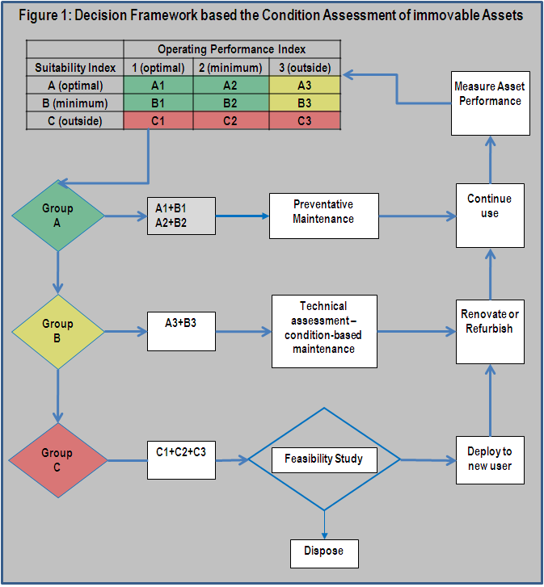
Process 6: Determine new immovable requirements
- A new asset requirement is determined when the all the User’s asset requirements cannot be met by its allocated assets (provided that the User has assessed the utilisation of allocated assets) or where the functional performance rating is “C”.
- Asset requirements that cannot be met through allocated assets, receives the highest priority.
- Where the functional performance rating is “C”, the User must prioritise new asset requirements based on functional performance and utilisation. The User’s total asset requirements must first be ranked according to its functional performance rating (where C3 receives the highest priority and C1 the lowest). Thereafter it is ranked according to condition rating (where the lowest condition receives the highest priority).
- The User must request the Custodian to analyse each asset option to determine:
  - the possibility of User allocating alternative assets that meets a higher functional performance standard; and
  - the cost of new assets to meet that required performance standard.
- The User must also determine whether non-asset solutions could be considered.
- The User and the Custodian should agree on an implementation programme to secure new assets as part of the budgeting process. The User should request funds from the relevant Treasury for new assets. The User and the Custodian must adjust such programme following the allocation of funds by the relevant Treasury.
- Template 1 & 2 should be utilised to consolidate new asset requirements resulting from the gap analysis and should be included as Annexure A & B of the U-AMP.

Process 7: Determine need for refurbishment or reconfiguration
- Priorities for refurbishment are determined based on functional performance and utilisation. The User’s existing assets must first be ranked according to the functional performance rating, with a rating of B3 receiving the highest priority and a rating of B1 the lowest. Thereafter, it is ranked according to utilisation, with the lowest utilisation receiving the highest priority.
- The User should request the Custodian to analyse each asset option to determine:
  - the possibility of User allocating alternative assets that meet a higher functional performance standard; and
  - the total cost to refurbish the asset to meet that required performance standard and improve the utilisation.
- The User and the Custodian should agree on an implementation programme to refurbish assets as part of the budgeting process. For example, this implementation programme should include the movement of personnel to temporary accommodation during the refurbishment, should it be required.
- The User must request funds from the relevant Treasury for refurbishment. The User and the Custodian must adjust such programme following the allocation of funds by the relevant Treasury. Template 3 should be utilised to consolidate refurbishment and reconfiguration requirements resulting from the gap analysis and should be included as Annexure C.

Process 8: Determine surplus assets to be surrendered
- Assets conforming to the following criteria should be earmarked for surrender to the Custodian:
  - assets with a performance standard of P1 (see Table 1); and
  - assets with a functional performance rating of C (see Table 6); or
  - where the Custodian has determined that the asset must be disposed of.
- An appropriate date to surrender the asset must be agreed upon with the Custodian. A User must give the Custodian at least six (6) months notice that it intends to surrender an asset. Template 4 could be used for assets to be surrendered to the Custodian and should be included as Annexure D of the U-AMP.

Process 9: Determine Maintenance (planned and unplanned)
- Where an asset is damaged, the User must request the Custodian to estimate the cost of reinstating the asset to the condition before the damage occurred. The User must request funds from the relevant Treasury to repair such an asset. Template 3a & 3b could be utilised to consolidate repair requirements and should be included as Annexure C of the U-AMP.

Process 10: Prepare budget requirements
- After completion of processes 1 to 9 taking cognisance of the cost inputs from the Custodian, budgets must be compiled in accordance with the MTEF requirements. Users are to utilise the relevant budget template as prescribed by National Treasury.
- Immovable asset lifecycles however may be in excess of sixty years, therefore spanning many MTEF cycles. Integrating immovable asset planning into the strategic planning processes using an immovable asset lifecycle approach presents a challenge. It is therefore important to incorporate all lifecycle costs into a longer planning cycle that will span several MTEF cycles.
- Budget information is obtained from the following processes:
  - Process 6: Determine new immovable asset requirements
  - Process 7: Determine the need for refurbishments or reconfiguration of existing immovable assets
- Process 6 provides information on capital budgets required for the acquisition of additional immovable assets. These projected budgets should be scheduled over the MTEF in accordance with the allocated priorities. Process 7 provides information on budget requirements for refurbishments or reconfigurations. These budgetary requirements should also be scheduled over the MTEF in accordance with allocated priorities.
- These budget requirements should be captured in template 5 for submitting new and existing capital budget bids as provided by National Treasury.

Part 4: Templates for preparing a U-AMP
- The following templates are provided to assist Users with the preparation of a U-AMP.
  - Template 1: EXTRACTION FROM ASSET REGISTER
(Annexure A of U-AMP).
  - Template 2: ADDITIONAL SPACE REQUIREMENTS
(Annexure B of U-AMP)
  - Template 3: INFRUSTRUCTURE REQUIREMENTS
3a: CAPITAL
3b: MAINTENANCE (applicable as Provincial requirement) (Annexure C of U-AMP)
  - Template 4: SURRENDER PLAN
(Annexure D of U-AMP)
  - Template 5: BUDGET REQIUREMENT:
(Annexure E of U-AMP)

Template 1: SCHEDULE OF ACCOMODATON REQUIREMENTS PER BUDGET PROGRAMME OBJECTIVE (Annexure A of U-AMP).

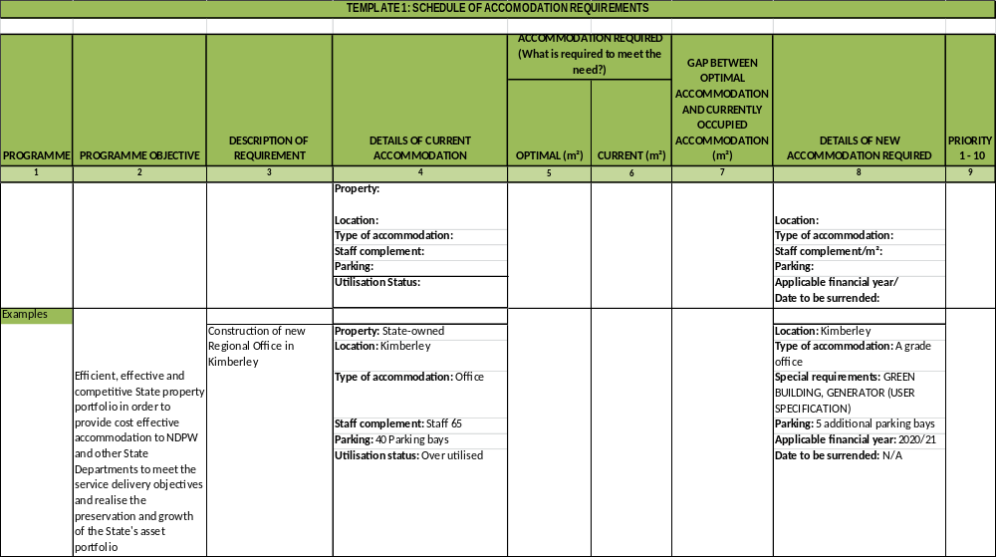

Template 2: PROPERTY (LEASED ACCOMMODATION) REQUIREMENTS (Annexure B of U-AMP)

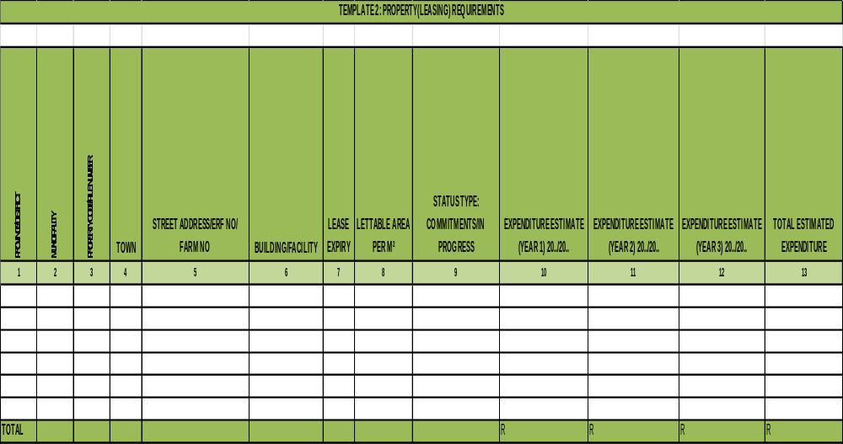

Template 3: INFRASTRUCTURE (CAPITAL ACCOMMODATION) REQUIREMENTS (Annexure C of U-AMP)

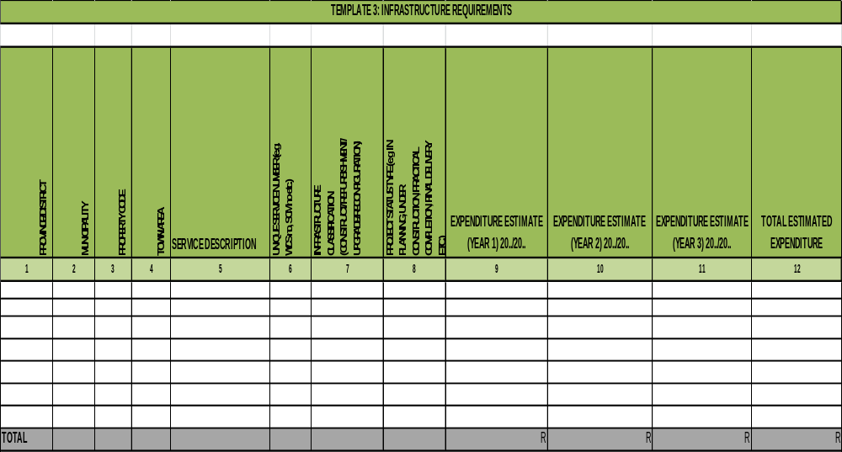

Template 4: BUDGET REQUIREMENTS: MEDIUM TERM EXPENDITURE ESTIMATE (Annexure D of U-AMP)
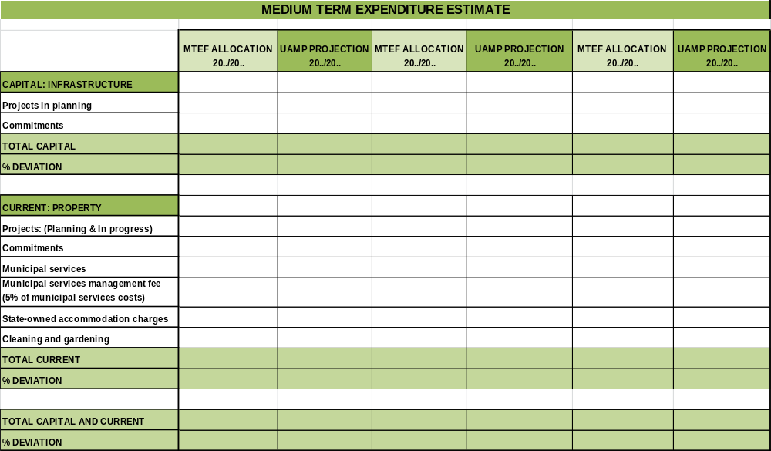

Part 5: Examples of Norms and Standards
- The following examples of norms and standards could guide the User when preparing a UAMP:

Methodology for determining functional performance of assets
- A critical aspect of a U-AMP is the assessment of the functional performance of an immovable asset. Functional performance is the measure which a User should apply to determine the extent to which an asset meets the asset requirements and thereby the service delivery objectives that such an asset supports. The paragraphs below describe a methodology that could be applied for accommodation. User may have to develop similar methodologies for other categories of assets where this functional performance methodology would not be applicable.

Required Performance Standard
- The application of a performance assessment requires the determination of a required (or ideal) performance standard. This required performance standard is the standard expected of the accommodation and will provide the baseline against which it should be measured. The required performance standard should be a strategic decision that will affect the management of immovable assets throughout their lifecycle. Table 1 can be used to determine the required performance rating.
Table 1: Required Performance Standard
Performance Standard | Condition Standard | Index
Highly sensitive functions with critical results or high profile public building | Assets to be in best possible condition, Only minimal deterioration will be tolerated | P5
Business operations requiring good public presentation and high quality working environments | Assets to be in good condition operationally and aesthetically, benchmarked against industry standards for that particular class of asset | P4
Functionally-focussed assets at utility level | Assets to be in reasonable condition, fully meeting operational requirements | P3
Functions are providing essential support only, with no critical operational role (e.g. storage) or asset has limited life | Condition needs to meet minimum operational requirements only | P2
Functions have ceased and the asset is dormant; pending relinquishment, etc | Condition can be allowed to deteriorate or marginally maintained at minimal cost | P1

Accessibility Rating
- The accessibility rating provides an indication of the asset’s physical location in relation to the service delivery objectives. This includes the accessibility of the accommodation for the general public, or members that have to conduct their business at the asset. The allocation of the accessibility rating has to take into consideration what is expected of the asset. Eg. A facility that does not require public access, should not be marked down on accessibility should it not provide for public access.
- Table 2 can be used to allocate an accessibility rating for the asset.
Table 2: Accessibility Rating
General Description | Rating
The asset fully support service delivery objectives; is fully accessible to the general public with well designed public areas and parking; is accessible for the physically challenged; and has all the services required by the functions performed in the accommodation. | A5
The asset mostly supports service delivery objectives; is fairly accessible to the general public with moderately designed public areas and parking; is accessible for the physically challenged to the main areas; and have the majority of services required by the functions performed in the accommodation. | A4
The asset partially support service delivery objectives; is accessible to the general public with limited public areas and parking; has limited accessibility for the physically challenged; and has the minimum services required by the functions performed in the accommodation. | A3
The asset limits achievement of service delivery objectives; is not generally accessible to the general public with limited public areas and parking; is not accessible for the physically challenged; and does not have the services required by the functions performed in the asset. | A2
The asset does not support service delivery objectives at all; is not at all accessible to the general public and should not be used for the current service delivery objectives | A1
e.g. The primary school has to be located where the public can have access to it, as well as adequate parking, etc. If it has limited accessibility it might score an A2.

Suitability Index
- The required performance standard allocated in Table 1 as well as the accessibility rating allocated in Table 2 is used as cross references to determine the suitability index of the asset as indicated in Table 3.
Table 3: Suitability Index
 | Accessibility Rating
Required Performance Standard | A1 (Very Poor) |  | A2 (Poor) |  | A3 (Fair) |  | A4 (Good) |  | A5 (Excellent)
P5 | C |  | C |  | B |  | A |  | A
P4 | C |  | C |  | B |  | A |  | A
P3 | C |  | B |  | B |  | A |  | A
P2 | C |  | B |  | A |  | A |  | A
P1 | C |  | C |  | C |  | C |  | C
A | The asset is fully suitable for its required function
B | The asset meets the minimum suitability criteria for its function
C | The asset does not meet the required suitability criteria

e.g. - The primary school has a required performance standard of P3 and an accessibility rating of A2. A cross reference will determine a suitability rating of “C”.

User Condition Rating
- The condition rating is utilised to give a brief indication of the physical condition of the asset (It should be noted that this is not a full condition assessment). Table 4 is used to allocate a condition rating to the asset.
Table 4: Condition Rating
Condition Status | General Description | Rating
Excellent | The asset has no apparent defects. Appearance is as new. Risk Index: No effect on service capability. No risk. | C5
Good | The asset exhibits superficial wear and tear, with minor defects and minor signs of deterioration to surface finishes. Risk Index: Intermittent, minor inconvenience to operations. Probability of risk to health & safety or property is slight. Low cost implication. | C4
Fair | The asset is in average condition, deteriorated surfaces require attention; services are functional, but require attention, backlog maintenance work exists. Risk Index: Frequent inconvenience to operations. Some risk to health & safety or property. Medium cost implications | C3
Poor | The asset has deteriorated badly, with some structural problems. General appearance is poor with eroded protective coatings; elements are broken, services are interrupted; significant number of major defects exists. Risk Index: Many disruptions to service capability, some risk to health & safety or property. High cost implication. | C2
Very Poor | The asset has failed; is not operational and is unfit for occupancy. Risk Index: Accommodation is unusable, immediate high risk to security, health & safety or property. Significant cost impact. | C1

e.g. The Primary School might be rated as C4.

Operating Performance Index
- The operating performance is determined by a cross reference between the required performance standard and the condition rating. Table 5 is used to determine the operating performance index.
Table 5: Operating Performance Index

 | Condition Rating
Required Performance Standard | C1 (Very Poor) | C2 (Poor) |  | C3 (Fair) |  | C4 (Good) |  | C5 (Excellent)
P5 | 3 | 3 |  | 3 |  | 2 |  | 1
P4 | 3 | 3 |  | 2 |  | 1 |  | 1
P3 | 3 | 3 |  | 2 |  | 1 |  | 1
P2 | 3 | 2 |  | 1 |  | 1 |  | 1
P1 | 2 | 2 |  | 1 |  | 1 |  | 1
1 | The asset standards exceeds the level expected for functional and operational requirements
2 | Functional Performance meets the standards expected for functional and operational requirements
3 | Functional Performance does not meet the standard expected for functional and operational requirements

e.g. The primary school had a required performance standard of P3 and a condition index of C4. The operating performance index for the Primary School will therefore be 2 (Good).

Functional Performance Index
- The functional performance rating is determined by utilising the suitability index as well as the operating performance index that was determined in the previous steps. Table 6 can be utilised to determine the functional performance rating.
Table 6: Functional Performance Index
 | Operating Performance Index
Suitability Index | 1 - Optimal | 2 - Minimum | 3 - Outside
Optimal - A | A1 | A2 | A3
Minimum - B | B1 | B2 | B3
Outside - C | C1 | C2 | C3

“A1” - The asset is operating optimally and is fully suitable for its required function
“A2” - The asset meets the minimum operating criteria and is fully suitable for its required function
“A3” - The asset does not meet the minimum operating requirements but is fully suitable for its required function
“B1” - The asset meets the optimal operating requirements but only meets the minimum suitability criteria for its required function
“B2” - The asset meets the minimum operating and suitability criteria for its required function
“B3” - The asset does not meet the minimum operating criteria but meets the minimum suitability criteria for its required function
“C1” - The asset is operating optimally but does not meet the minimum suitability criteria
“C2” - The asset meets the minimum operating criteria but does not meet the minimum suitability criteria
“C3” - The asset does not meet the minimum operating criteria and does not meet the minimum suitability criteria

e.g. The primary school was allocated a C for suitability and a 2 for operating performance. The functional performance in accordance with Table 6 is therefore C2 which means that the accommodation is operating well but is not necessarily suitable in terms of its accessibility.

- The functional performance index should be utilised by the User to select the appropriate action for the asset. The following diagram illustrates the actions.

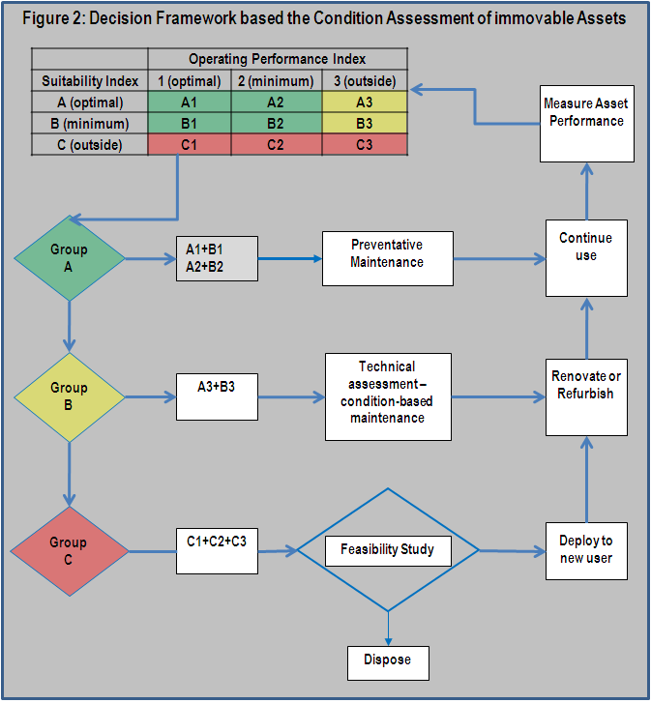

Summary of Space Planning Norms and Standards
A. Overall Space Norms
A.1 Gross construction area per Full Time Employee (FTE)
Applicable to: New office buildings procured by government
Measure |  |  | Norm
Gross construction divided by number of FTEs |  |  | Average gross construction area per FTE should not exceed 24m²
A.2 Workspace area per FTE
Applicable to: All office space used (included leased space) by government
Measure |  |  | Norm
Workspace area divided by number of FTEs |  |  | Average workspace area per FTE should not exceed 12m²
B. Workspace Norms
B.1 Workspace area per function
Applicable to: All office space used (included leased space) by government
Function | Spatial requirements | Norm |  | Notes
Administration | Open-plan. Some local storage. | Workspace area should be between 6-8m² |  | - Standard hard wearing modular furniture should be used.  - All workspaces should have a daylight factor of at least 10%.  - Refer to definition of “open-plan” in glossary.
Technical & Management | Open-plan. Some layout space and or space for large equipment such as drawing boards. | Workspace area should be between 8-16m²
Senior Management | Open-plan or cellular offices. Requirement for some privacy and space for small meetings. | Workspace area should be between 16-20m²
Executive Management | Cellular offices. Requirement for privacy and space for small meetings. | Workspace area should be between 20-25m²
B.2 Support space per workspace area
Applicable to: All office space used (included leased space) by government
Function | Example | Guide |  | Notes
Workspace support | Meeting rooms, rest rooms, catering, storage, information management, tea rooms, crèches and parking | Support space is usually between 55% to 65% of workspace area |  | 1. Executive management such as Ministers and Director Generals have additional spatial requirements in the form of additional storage and large meeting spaces.
B.3 Core space per workspace area
Applicable to: All new buildings, either owned or leased by government
Function | Example | Guide |  | Notes
Organisation support | Circulation, technical support and facilities management | Core space is usually between 65% to 85% of workspace area |  | 1. Centralised meeting areas: These should be easily accessible to both building Users and visitors. They are therefore likely to be near the main entrance and on the ground floor.
B.3 Structural space per internal area (workspace + workspace support + core)
Applicable to: All office space used (included leased space) by government
Structure | Example | Guide |  | Notes
Structure | External walls, internal walls, structural columns | Structural space should not exceed 10% of (workspace + workspace support + core space areas) |  | 1. Building must be designed to enable a range of different office layouts, allowing change to be accommodated.

Utilisation Assessment for office accommodation
- The level of utilisation of assets is measured against Space Planning Norms & Standards as prescribed by the Minister of Public Works. The approach of the utilisation assessment is to first determine the required space in terms of the organisational structure/functions as informed by the Space Planning Norms & Standards and legislation. This indicator is then measured against the actual space occupied by the organisation that is expressed as a percentage. The following example is based on office accommodation only.
- Step 1: Determine the overall space required, in terms of the organisation’s structure, aligned with the Space Planning Norms & Standards as prescribed by the Minister of Public Works. The following process should be used to this effect:
  - Categorise the organisational structure into the following functional areas:
  - Executive Management
  - Senior Management
  - Technical/Management
  - Administration
  - Using table 7, calculate the amount of space required for each functional area, based on the number of posts per functional area. This space includes workspace, workspace support and core space.
 | Organisational Unit | Area
 | Executive | 47.00
 | Senior Management | 37.60
 | Technical | 18.80
 | Administration | 14.10
- Step 2: Determine the amount of space currently occupied by the organisation, as obtained from Template 2a provided by the Custodian.
- Step 3: Divide the space currently occupied (Step 2) by the required space in terms of the Space Planning Norms & Standards (Step 1) and express it as a percentage. A percentage under 100% indicates that the organisation has too much space that it currently occupies and the accommodation is therefore under-utilised. e.g. Should the organisation currently occupy 102m² and is required to have 183.30m² the calculation will be as follows:
(183/102)*100 = 179%
This implies that the organisation’s accommodation is 79% over-utilised; i.e. the organisation requires 79% more space to accommodate its staff. Should the organisation currently occupy 250 m² and is required to have 183 m² the calculation will be as follows:
(183/250)*100=73%)
This implies that the organisation’s accommodation is 73% utilised, i.e. the organisation has 27% more space than what it requires.

Maintenance must be aimed at preserving the condition of the State’s immovable assets to the extent that they will continue to support the current service delivery objectives and strategies of a User and to comply with legislation (e.g. Occupational Health & Safety Act, National Building Regulations etc). The custodian of an immovable asset needs to plan for maintenance as part of the custodian immovable asset management plan.
See Table 6.
See Table 4.

